**BLUETOOTH LE DEVELOPMENT KIT**

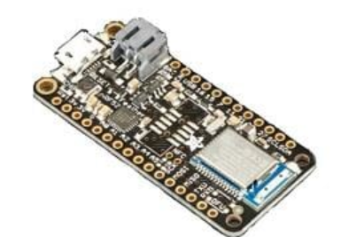

**Specifications**

Adafruit Feather nRF52 Bluefruit LE is an all-in-one Arduino-compatible and Bluetooth Low Energy (BLE) development board. This board comes with built-in USB and battery charging and allows you to run code directly on the nRF52832. Single MCU results in better performance, low power consumption, and low production cost. The board features ARM Cortex M4F processor clocked at 64MHz with 1.7V to 3.3V logic. The development board's chip offers 512KB of flash and 64KB of SRAM, and the USB provides USB-to-Serial program and debug capability.

## **FEATURES**

* Measures 51mm x 23mm x 7.1mm without soldered headers
* Weight 5.7g
* ARM M4F @ 64MHz with 1.7V to 3.3V logic/power
* No EEPROM
* Up to +4dBm output power
* Built in USB Serial converter
* 19 GPIO pins
* Hardware floating point acceleration
* 12 PWM pins
* 8 analog inputs
* Built-in 100mA lipoly charger with charging status indicator LED
* Power/enable pin
* 4 mounting holes
* Reset button